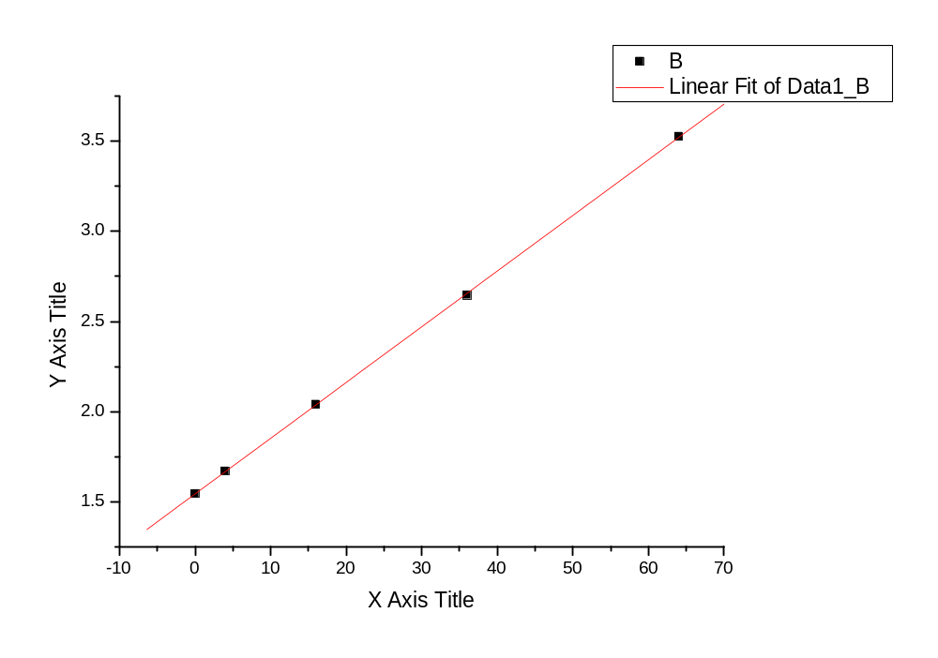
附图：I－d 拟合直线图
相关系数：
Linear Regression for Data1_B:
Y = A + B * X

Parameter Value Error
------------------------------------------------------------
A 1.54199 0.00459
B 0.03093 1.36246E-4
------------------------------------------------------------

R SD N P
------------------------------------------------------------
0.99997 0.00719 5 <0.0001
------------------------------------------------------------

